Lagged cross-correlation: EURUSD and USDJPY
Method 12 / daily log returns / K_max=10 / Alpari D1 full available history

Study setup
Logical pair: EURUSD , USDJPY
Broker symbols: EURUSD_i , USDJPY_i
Snapshot: 2026-11-03_majors_alpari_D1
Timeframe: D1
Matched return window: 1999-01-05 to 2026-11-02 (UTC bar dates)
Matched return count n: 7200
Dropped unfinished last bar dated 2026-11-03 UTC after a tick-volume check against the prior complete day.
Lag definition: rho_X->Y(k) = Corr(x_t, y_{t+k}) on matched D1 bars
K_max = 10; headline lag k = 1 (both directions)
Complete matched rows (Excel): EURUSD-USDJPY_Lagged_D1.xlsx
Complete matched rows (HTML table): EURUSD-USDJPY_Lagged_D1_data.html

Method carried forward
Lagged cross-correlation measures Pearson correlation between matched daily log returns of close, ln(close_t / close_t-1), after shifting one series forward by k bars on the matched panel. Quotes are not inverted. rho_{X->Y}(k) = Corr(x_t, y_{t+k}) with n_k = n - k. K_max = 10 is fixed before estimation. The headline is the pre-specified lag k = 1 in both directions. k = 0 is the same-bar side check. The lag inside 1..10 with the largest absolute rho is stored as a descriptive column only; it is not a selected result. This is a linear screen, not proof of forecast edge, economic cause, or a trading signal.

Results (headline k=1)
rho_EURUSD->USDJPY(1): -0.009482 (n=7199)
95% Fisher interval EURUSD->USDJPY: [-0.032575, 0.013622]
rho_USDJPY->EURUSD(1): 0.024939 (n=7199)
95% Fisher interval USDJPY->EURUSD: [0.001839, 0.048012]
Same-bar rho(k=0): -0.300952
Largest |rho| among k=1..10 (descriptive only, not selected): EURUSD->USDJPY k=5 rho=-0.017787; USDJPY->EURUSD k=1 rho=0.024939

CCF table
k | rho_EURUSD_to_USDJPY | n_EURUSD_to_USDJPY | rho_USDJPY_to_EURUSD | n_USDJPY_to_EURUSD
0 | -0.30095222 | 7200 | -0.30095222 | 7200
1 | -0.00948176 | 7199 | 0.02493864 | 7199
2 | -0.01074168 | 7198 | -0.00035303 | 7198
3 | 0.0092803 | 7197 | -0.00809063 | 7197
4 | 0.01501697 | 7196 | -0.00528566 | 7196
5 | -0.01778743 | 7195 | 0.01069432 | 7195
6 | 0.00381973 | 7194 | -0.01595273 | 7194
7 | 0.00592918 | 7193 | 0.00594933 | 7193
8 | -0.00484956 | 7192 | -0.0167895 | 7192
9 | -0.01563134 | 7191 | -0.00838702 | 7191
10 | -0.01482495 | 7190 | -0.01100066 | 7190

Conclusion
At the pre-specified lag k=1 for EURUSD and USDJPY, rho_{EURUSD->USDJPY}(1) = -0.0095 (n=7199) and rho_{USDJPY->EURUSD}(1) = 0.0249 (n=7199). Same-bar rho(k=0) = -0.3010. Largest |rho| among k=1..10 is descriptive only: EURUSD->USDJPY at k=5 (-0.0178); USDJPY->EURUSD at k=1 (0.0249). This is a linear screen, not forecast proof or a trading signal.

Charts
Daily closes

Daily log returns

CCF both directions k=0..10
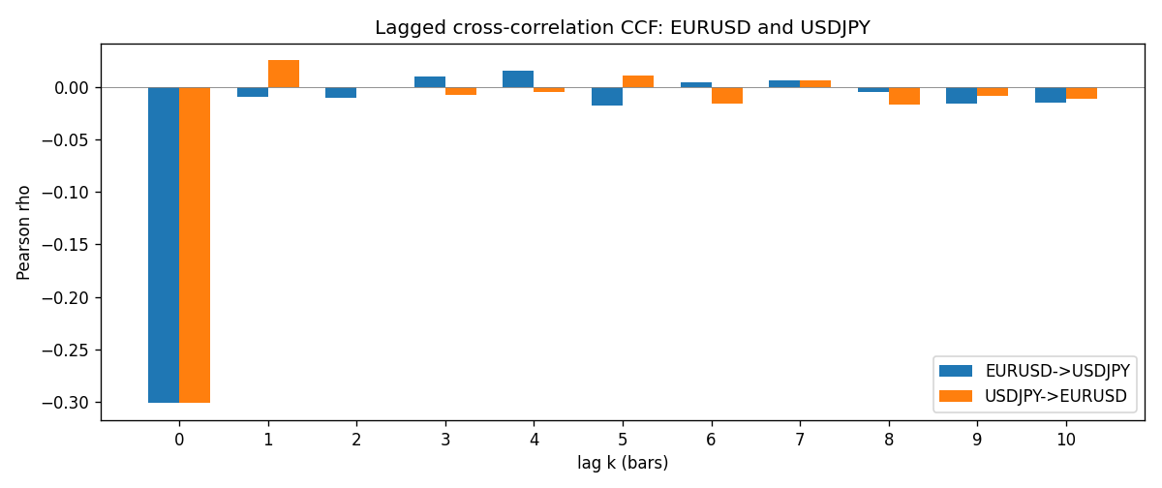

Data report
Every matched row is stored in the sibling Excel workbook named EURUSD-USDJPY_Lagged_D1.xlsx (sheet matched_rows). The CCF sheet holds rho(k) for k=0..10. Embedding all rows as a Word table is impractical; the Word file holds column summaries and the first and last 15 rows.
Columns: time, EURUSD_open, USDJPY_open, EURUSD_high, USDJPY_high, EURUSD_low, USDJPY_low, EURUSD_close, USDJPY_close, EURUSD_tick_volume, USDJPY_tick_volume, EURUSD_spread, USDJPY_spread, EURUSD_real_volume, USDJPY_real_volume, EURUSD_log_return, USDJPY_log_return
Column summaries (matched calculation rows)
column | count | mean | std | min | 25% | 50% | 75% | max
EURUSD_open | 7200 | 1.1812699 | 0.15089907 | 0.8272 | 1.086045 | 1.16609 | 1.2939325 | 1.5995
USDJPY_open | 7200 | 113.80877 | 19.206548 | 75.693 | 104.4225 | 110.983 | 120.69125 | 163.824
EURUSD_high | 7200 | 1.1864006 | 0.15149686 | 0.8326 | 1.0901575 | 1.17121 | 1.2991625 | 1.6038
USDJPY_high | 7200 | 114.3063 | 19.268128 | 76.001 | 104.878 | 111.441 | 121.26 | 163.978
EURUSD_low | 7200 | 1.1762568 | 0.15022122 | 0.8227 | 1.0819775 | 1.162475 | 1.288265 | 1.5865
USDJPY_low | 7200 | 113.28572 | 19.134551 | 75.402 | 103.8875 | 110.53 | 120.17 | 163.628
EURUSD_close | 7200 | 1.1813075 | 0.15087411 | 0.8267 | 1.085995 | 1.16602 | 1.2939425 | 1.5997
USDJPY_close | 7200 | 113.82186 | 19.221964 | 75.811 | 104.4165 | 111.023 | 120.6855 | 163.851
EURUSD_tick_volume | 7200 | 103020.56 | 173417.03 | 218 | 9398.5 | 52714 | 99443.25 | 1471626
USDJPY_tick_volume | 7200 | 106139.77 | 179306.98 | 149 | 9927.5 | 53095 | 92761 | 1803508
EURUSD_spread | 7200 | 19.389444 | 16.57873 | 0 | 8 | 12 | 30 | 50
USDJPY_spread | 7200 | 20.3175 | 17.636173 | 0 | 6 | 11 | 30 | 50
EURUSD_real_volume | 7200 | 4.0252061e+10 | 1.6676396e+11 | 0 | 0 | 0 | 0 | 3.6149665e+12
USDJPY_real_volume | 7200 | 3.4708591e+10 | 1.6077621e+11 | 0 | 0 | 0 | 0 | 3.8834203e+12
EURUSD_log_return | 7200 | -1.012e-05 | 0.00580063 | -0.03123819 | -0.0032472 | 0 | 0.00325137 | 0.03433183
USDJPY_log_return | 7200 | 4.989e-05 | 0.00620383 | -0.03908203 | -0.00319719 | 0.00011638 | 0.00340925 | 0.05184024
First 15 matched rows (selected columns)
time | EURUSD_close | USDJPY_close | EURUSD_log_return | USDJPY_log_return
1999-01-05 | 1.1758 | 111.92 | -0.0048360507 | -0.00017868311
1999-01-06 | 1.1623 | 112.77 | -0.011547966 | 0.0075660159
1999-01-07 | 1.1712 | 111.33 | 0.0076280636 | -0.012851583
1999-01-08 | 1.1585 | 110.8 | -0.010902799 | -0.0047719894
1999-01-11 | 1.1503 | 109.02 | -0.007103287 | -0.016195423
1999-01-12 | 1.1555 | 112.6 | 0.0045103728 | 0.032310364
1999-01-13 | 1.1681 | 113.52 | 0.010845346 | 0.0081373171
1999-01-14 | 1.1681 | 113.52 | 0 | 0
1999-01-15 | 1.1563 | 114.15 | -0.010153245 | 0.0055343401
1999-01-18 | 1.1605 | 114.16 | 0.0036256946 | 8.7600193e-05
1999-01-19 | 1.1603 | 113.52 | -0.00017235436 | -0.0056219403
1999-01-20 | 1.1566 | 112.91 | -0.0031939256 | -0.0053879917
1999-01-21 | 1.1601 | 113.87 | 0.0030215416 | 0.0084664056
1999-01-22 | 1.1587 | 114.56 | -0.0012075213 | 0.0060412564
1999-01-25 | 1.1552 | 113.72 | -0.0030251979 | -0.0073594164
Last 15 matched rows (selected columns)
time | EURUSD_close | USDJPY_close | EURUSD_log_return | USDJPY_log_return
2026-10-13 | 1.11965 | 158.305 | 0.0037402957 | -0.0018932826
2026-10-14 | 1.11545 | 158.317 | -0.0037582255 | 7.5800166e-05
2026-10-15 | 1.12172 | 158.024 | 0.0056053107 | -0.0018524319
2026-10-16 | 1.12371 | 157.964 | 0.0017724895 | -0.00037976126
2026-10-19 | 1.12086 | 158.517 | -0.0025394633 | 0.0034946841
2026-10-20 | 1.12354 | 158.16 | 0.0023881672 | -0.0022546642
2026-10-21 | 1.12318 | 158.108 | -0.00032046717 | -0.00032883504
2026-10-22 | 1.12139 | 156.755 | -0.0015949606 | -0.0085942669
2026-10-23 | 1.11989 | 156.81 | -0.001338521 | 0.00035080446
2026-10-26 | 1.11735 | 157.458 | -0.0022706559 | 0.0041238746
2026-10-27 | 1.11272 | 157.894 | -0.004152342 | 0.0027651658
2026-10-28 | 1.1152 | 157.743 | 0.0022262927 | -0.00095679538
2026-10-29 | 1.11772 | 157.683 | 0.0022571351 | -0.00038043789
2026-10-30 | 1.11644 | 157.516 | -0.0011458446 | -0.0010596481
2026-11-02 | 1.11881 | 157.933 | 0.002120569 | 0.0026438521

